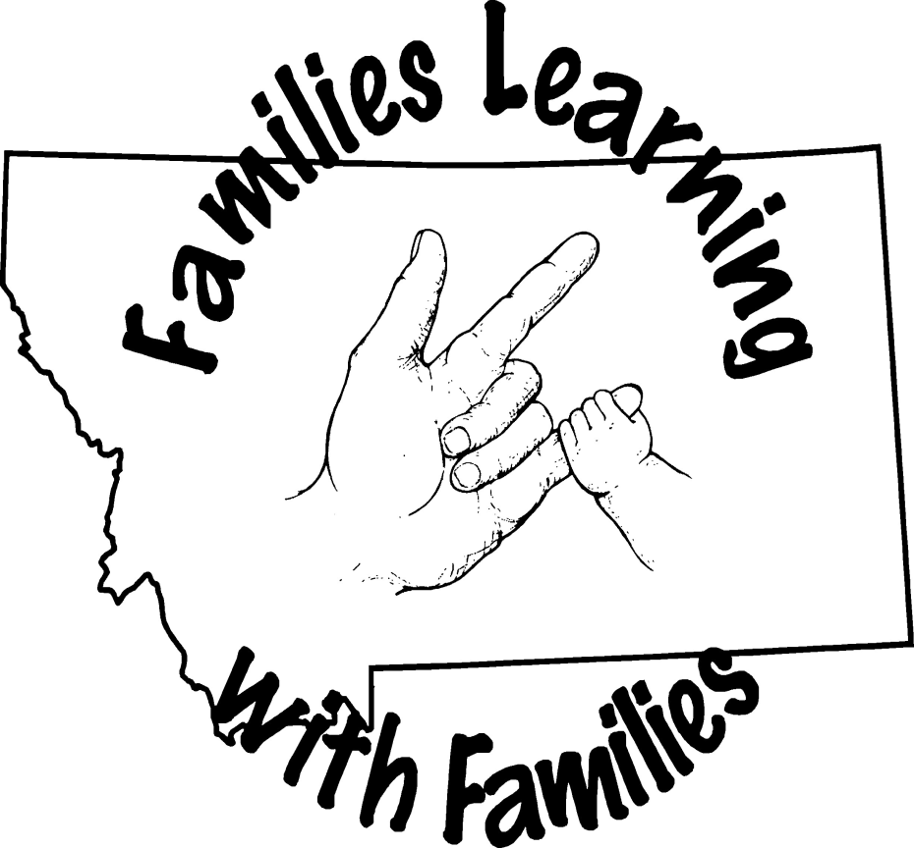
23rd Annual
FAMILY LEARNING WEEKEND for
FAMILIES OF Deaf and Hard of Hearing Children
May 31, June 1-2, 2019

What: MSDB 23rd Annual Family Learning Weekend for the Deaf and Hard of Hearing
Where: MSDB Campus in Great Falls
When: May 31, June 1-2, 2019
Who: Families of Deaf and Hard of Hearing Children living in Montana!
Why: IT WILL BE FUN!!

The Learning Weekend is a creative program providing opportunities for families of sensory impaired children to learn about deafness, share their experiences with other families, and learn how to communicate more fully with one another in a warm, caring atmosphere.

The focus of the weekend is to enhance each individual’s personal knowledge of deafness and how it relates to the education and development of their child. Informal workshops, group discussions (parent groups, kids’ groups, siblings’ groups, etc.) and hands-on activities will be offered. Child care and recreation for the children (siblings included) is available at no charge. Families will be reimbursed for mileage at the current state rate.

Housing is provided on a first-come first-serve basis. Each family is generally provided with their own suite of rooms in the cottages and efforts are made to make assignments according to individual needs and preferences. Typically each family has their own bathroom, sometimes two, depending on the size of the family. Participants need to bring personal items such as soap, shampoo and toothpaste. The MSDB Swimming Pool is OPEN!!!! Please bring your swimming suit. There will be time for the kids to swim and family swim later on Saturday.

Children’s Programs:
The children are divided into groups based mostly on age. Many factors are taken into consideration including friendships, maturity level, and interests when putting together the groups. The children stay with their groups until they join the parents for mealtime. MSDB’s finest residential and school staff will be responsible for supervising your children and making sure they enjoy the day as much as you do!

Birth to two: Children will be in the pre-school room in Bitterroot with staff. Parents should pick up their children prior to lunch and dinner and return them to the same location when they are done eating.
Three to five: Children will be involved in a variety of activities throughout the day. These activities will include snacks, program practice, indoor and outdoor activities including a trip to the MSDB playground (weather permitting). The activities for this group will remain flexible depending on the ages and abilities of the participants.

Six through eighteen: Saturday morning after the group picture, children will re-join their assigned teams which are designed for children to be involved with peers. There will be several activities including program practice, recreation activities and snacks. In addition, a representative from the Montana Telecommunications Access Program (MTAP) will have fun projects for the children to enjoy. MTAP will talk about technology, including using a VP, the Video Relay Service, etc. Also during the morning session MSDB Counselors will meet with hearing siblings providing them an opportunity to discuss their feelings regarding having a deaf sibling. Deaf and Hard of Hearing children will meet separately to share their thoughts as well. This information (while names confidential) will be shared with the parents during the Sunday morning presentation.

***The kids program is intended to provide entertainment and educational activities that will further the participants understanding of deafness and its impact on the family. Activities are designed for youth with hearing loss and for their siblings. Participants are grouped by age and staff are assigned accordingly, depending on the numbers of the participants and their individual needs. If you have unique concerns regarding your child, please let us know and we will work with you to insure that everyone has a good time.
Information from various vendors (serving Deaf and Hard of Hearing) will be available throughout the weekend.

Presenter Bios
not all bios were available at press time

Still waiting on several bios for this section.

John Fechter
As a volunteer for more than twenty years, John currently serves as board president for Minnesota Association of Deaf Citizens (MADC.) He also served as president of Metro Deaf School (MN) Board. At Hamilton Relay, John is responsible for directing outreach personnel and managing activities to ensure that all state outreach is carried out according to specific objectives. He works with outreach staff to ensure effective communication with relay users on new development and service enhancements in each of their states. A graduate of Gallaudet University, John resides near Minneapolis, MN and has two children who are both deaf. They are currently students at Gallaudet University, majoring in Social Work and Elementary Education. John has been to all 50 states and enjoys traveling.

Dr. Jane R. Madell, PhD FAAA, CCC A/SLP, LSLS Cert AVT
Dr. Madell is an audiologist, speech-language pathologist, and LSLS auditory verbal therapist. Her clinical and research interests include hearing in infants and children, management of severe/profound hearing loss, including HA’s, CI’s, FM’s, and auditory processing disorders. She has published 7 books, numerous book chapters, and articles. She writes the Hearing and Kids section of the HearingHealthMatters.com blog. She is the recipient of the Marion Downs Award for Excellence in Pediatric Audiology. She is producer and director with Irene Taylor Brodsky of the film The Listening Project which interviews 15 young adults with hearing loss. Dr. Madell presents nationally and internationally on topics related to hearing loss in children.

Tami Santimyer earned a BA in English at California State University, Northridge, and a Master's in Linguistics at Gallaudet University. She did a number of theatrical shows, namely Nobody's Perfect (based on Marlee Matlin's book) that was first premiered at Kennedy Arts Center in Washington, D.C. and later toured the country because of popular demand. She also did Children of a Lesser God on Broadway. She also taught five years at Model Secondary School for the Deaf in Washington, D.C. and directed a number of theatrical productions on the side. She has been working in college admissions for six years now at Gallaudet University, helping D/HH students with transitioning from high school to college. She is currently working on getting her EdD in Educational Leadership and Management at Drexel University

Pamela C. Snedigar, MPA Is currently the Director of the Gallaudet University Regional Center –West (GURC-West) at Ohlone College in Fremont, CA. She is a lifelong resident of the Bay Area, where her deaf parents settled. Pam received her B.S., Paralegal Certificate and her Masters in Public Administration from California State University Hayward. She was a paralegal at the California Center for Law and the Deaf (CalCLAD) for 10 years; in that capacity she provided direct services, legislative review, advocacy training and community education.

Her interests and current position at GURC-West, have led her to develop many training and continuing education opportunities for professionals and families in the Western United States. She has chaired or been on core planning committees for a number of state-wide, regional and national conferences, including the California Educators of the Deaf Conference, Western Symposium on Deafness, National Asian Deaf Congress Conference, Intermountain Special Studies Institute, Children of Deaf Adults Conference and the American Sign Language Roundtable. She has also been involved with parent outreach through partnerships with programs available in the states of Montana and Washington.

Deaf Learning Weekend 2019 Schedule
(subject to change)
Friday, May 31, 2019
4:00-6:00 | Check in: Yellowstone Cottage. Room Assignments and Family Picture
5:00 | Tour: Especially helpful for first time attendees. Meet in the Yellowstone Lobby.
5:30-6:20 | Dinner: Pizza, salad and dessert in the MSDB main dining room.
6:30-6:50  7:00-7:15  7:15-7:45 | Welcome: Parents and children in the Mustang Center (Gym).  All children (except the White Team) will remain in the Mustang Center. Parents will go to Bitterroot.  Introduction: (IMC)  Ice Breaker: Getting to know the participants a bit earlier in the weekend.
8:00-8:45 | Successful Deaf Adult Panel: Pre-selected adults will share their journey. This is a very powerful session for the audience as well as the panel members!
9:00 | Pick up your kids from the Mustang Center.
Saturday, June 1, 2019
7:45-8:45 | Breakfast in the main dining room.
8:45-9:00 | Group Picture – All Participants together in front of the big sign (each family will get a “Memory Book” at the end of the weekend to take home).
9:00-10:15 | Session 1  Tami Santimyer- Parental Involvement as an Important Factor for Grabbing Opportunities  This workshop introduces parents to the importance of encouraging children to grab opportunities in order to grow. Helps parents recognize their role in promoting personal and professional growth in their child. Identifies ways parents can help starting early.
10-15-10:30  10:30-11:45  11:45:-12:45 | Break  Session 2  - Tami Santimyer - continued presentation  Lunch in the Dining Room
12:45-1:05 | Kid’s Program - Mustang Center (Gym)
1:05-1:10  1:15-3:15 | Parents back to the IMC  Dr. Jane Madell – “It's Not the Same Old Deafness" – See bio for information on her presentation.
3:15-3:30 | Break
3:15-4:30 | Parent Groups  - Mom’s Group - Conference Room in the Basement  - Dad’s Group – Life Skills Room  - Grandparent (other caregiver) Group - (if enough interested)- Outreach Office
4:45-6:00  6:00-7:00 | OPEN SWIM FOR FAMILIES  BBQ: Dinner in the main dining room
7:00-7:30 | Introduction to the Deaf Mentor Program for Montana
7:30-9:00 | Parent Panel – This is always a very popular session for both the presenters and the participants in the audience - IMC
9:00 | Pick up your kids from the cottages as they will be watching movies and eating snacks
Sunday, June 2, 2019
7:45-845 | Breakfast in main the Dining Room
9:00-9:45  9:45-10:00 | John Fetcher - Hamilton Relay and MTAP  Break
10:00-10:30  10:30-11:00  11:00-11:30  11:30  1:00 | Sorensen and MTAP Equipment demo  Sibling Summary  Closing – evaluations, Family “Memory Book”  Lunch – Dining Room  Everyone should be on their way! Have a wonderful summer travel safe!
23rd Annual
FAMILY LEARNING WEEKEND for
FAMILIES OF Deaf and Hard of Hearing Children
May 31, June 1-2, 2019

WHAT OTHERS HAVE SAID ABOUT MSDB’s FAMILY LEARNING WEEEKENDS!

"I think every family with a deaf child should come to at least one to see if it’s helpful to them – we love it and learn each and every time we come to MSDB!”

"I like that my brother feels welcome and fits in every time he is here and I support him."

"I was very impressed with MSDB in general. I had no idea that this was such a 'gem'. Montana is very lucky."

"Informative, we met a lot of amazing families, the staff was great and the kids had fun”

"Seeing all the kids together is the best part! We always learn something new that helps us with our lives!"

"The staff are great, always different options for presenters – changes every year”

SPONSORED BY:
The Montana School for the Deaf and the Blind The M.S.D.B. Foundation, Inc.
Gallaudet University Regional Center – West at Ohlone College The Montana Office of Public Instruction

Montana School for the Deaf and the Blind
3911 Central Avenue
Great Falls, MT
59405

1 800 882-MSDB

www.msdb.mt.gov Mailing Label

