Montana School for the Deaf and the Blind

Health and Safety Manual
Revised May 2021

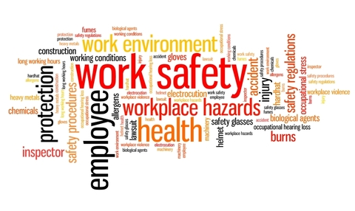






[Visual 1MSDB Logo 4 blue boxes featuring yellow fingerspelling and braille.
Montana School for the Deaf and the Blind written below boxes.]

TABLE OF CONTENTS

MSDB Health and Safety Policies…………………………………………..Page 2-4

Responsibilities………………………………………………………………Page 5-7

Safety Committee…………………………………………………………….Page 8

Reporting & Recording………………………………………………………Page 8-9

Return to Work……………………………………………………………....Page 9

Safety Rules………………………………………………………………… Page 9

Evacuation Procedures……………………………………………………….Page 10

Appendix 1 – Resources……………………………………………………..Page 11

Appendix 2 – Safety Training/Certification…………………………………Page 12

Appendix 3 – MSDB Accident–Injury Report…..………………...……….. Page 13

Appendix 4 – State Fund “First Report of Injury” Form…………………… Page 14

Appendix 5 – Tort Claims Report of Incident Form………………………. Page 15-16

Employee Acknowledgement………………………………………………. Page 17

MSDB Health and Safety Policies

The Montana School for the Deaf and the Blind (MSDB) places a high value on the safety of its employees and is committed to providing a safe workplace. We have developed this injury prevention program to involve management, supervisors, and employees in identifying and eliminating workplace hazards and promoting safe work practices.

8300 Montana Safety Culture Act
In compliance with the Montana Safety Culture Act, MSDB has established an education-based safety program that requires at a minimum a safety training program for new employees focusing on general safety orientation:
Job or task-specific safety training and continuous refresher safety training
Periodic hazard assessment with corrective actions identified
Appropriate documentation of performance of the activities
Established Safety Committee

8301 Safety Program
The Board acknowledges the importance of safety for students, staff, and others having business with MSDB. Safety education, accident prevention, and proper supervision are important as protective measures. Additionally, OSHA (Occupational Safety and Health Administration, http://www.osha.gov ) regulations and guidelines are adhered to and are meant to promote a culture of safety. See policies below.

SCHOOL POLICY#
3417 Communicable Diseases
5227 Drug-free Workplace
5225 Tobacco Free Policy
9350 School-wide Asbestos Program

The Board directs the formation of a Safety and Facilities Committee comprised of employer and employee representatives, as outlined in the Montana Safety Culture Act. In compliance with Board policies, the Board directs the development of an Exposure Control Plan and rules for employees to eliminate or minimize work-related exposure to communicable diseases, blood-borne pathogens, particularly Human Immunodeficiency Virus (HIV) and Hepatitis B Virus (HBV), drugs, alcohol, or tobacco products, and asbestos. See the policies above.

SCHOOL POLICY#
4315 Spectator Conduct and Sportsmanship for Athletic and Co-curricular Events
4330 Community Use of School Facilities
8302 Dangerous Person on Campus
8310 Disaster Drills and Emergency Evacuation

MSDB has developed and maintains comprehensive crisis and emergency response plans that address all threats to students, staff, visitors and property. The plan addresses all threats caused by individuals, nature or weather and will provide guidelines and procedures for an immediate and safe response that protects human welfare as well as property. Students and staff will receive regular training on the implementation of safety procedures outlined in the safety protocol sheet.

MSDB participates in the prosecution of any individual(s) who may disturb any processes, personnel, or property. This includes insulting or abusing any school employee or student during the course of the school/work day. Or otherwise violate the laws of the State of Montana regarding school disturbance or individual protection for school employees or students.

It shall be the Superintendent’s responsibility to execute this program. The Superintendent may delegate this responsibility to other staff members. See the policies above.

SCHOOL POLICY#
4301 Visitors to the School and Residential Facilities
4313 Disruption of School Operations
5222 Evaluation of Non-Administrative Staff

Each employee is responsible for complying with all MSDB safety rules, working in a safe manner at all times, and reporting safety concerns and injuries to a supervisor immediately. Employees are encouraged to actively participate in identifying ways to make our school a safer place to work and communicating safety ideas and practices to management.

Supervisors are responsible for the safety of their employees and as part of their daily duties must check the workplace for unsafe conditions, watch employees for unsafe actions, and take prompt action to eliminate any hazards and correct unsafe behavior.

The administration devotes every opportunity and provides the resources necessary to promote safety. MSDB maintains a system for identifying and correcting hazards and plans for foreseeable emergencies. MSDB provides initial and ongoing training for employees and supervisors and enforces a disciplinary policy to ensure that safety is not compromised. See the policies above.

SCHOOL POLICY#
2510 School Wellness
3300F Student Incident Report Form
3410 Student Health/Physical Screening/Examinations
3413 Student Immunizations
3415 Emergency Illness/Accident
3415F Accident – Injury Report
3416 Referral of Students to the Health Services
4320 Contact with Students
5122 Fingerprints and Criminal Background Investigations
5130 Staff Health
5132 Employee Illness and Food Services
5230 Prevention of Disease Transmission
5232 Abused and Neglected Child Reporting
5700 Student Supervision
5701 Employee Contact with Students
5710 Use of Force
8230 Nutrition

MSDB is committed to providing an environment that promotes and protects students’ safety, health, well-being, and ability to learn by supporting healthy eating and physical activity. The Superintendent will ensure that goals are developed and procedures implemented which promote student safety and security, physical health and well-being, nutrition education, physical education, nutrition standards for all food and beverages served, school-based wellness activities and oversight and evaluation of all goals. See the policies above.

SCHOOL POLICY#
9300 Operation and Maintenance of District Facilities
9320 Security
9320P Procedure of the Control of Access to School Buildings and Grounds
9330 Facilities Operations
9331 Snow Removal
9350 School-wide Asbestos Program

Facilities and grounds are maintained to provide safe, secure work and living environments for all students and staff. The administration has developed a schedule and program to maintain and/or upgrade the buildings and grounds of the school. Facilities represent a long-term investment for the State of Montana and the school. The functionality and safety of school facilities can be enhanced with a regular maintenance program monitored by staff. See the policies above.

SCHOOL POLICY#
8100 Transportation
8121 School-Owned Vehicles
8122 School Owned Vehicle Emergencies
8345 Use of Personal Cars for School Business

The nature of MSDB’s Student Life and Outreach Programs result in significant amounts of travel for students and staff. The Board and the State have established policies and procedures to minimize exposure to risk of injury during transport of students and work-related travel by staff. Staff and students are expected to comply with all rules and guidelines for safety when traveling in school vehicles or on school-related business. All Outreach staff are required to complete a defensive driving course hosted by the Department of Administration, Risk Management and Tort Defense Division. See the policies above.

MSDB considers all injuries and incidents to be preventable and that through the active participation of all employees in working safely we can eliminate work place injuries. It is the basic safety policy of MSDB that no task is so important that an employee must risk injury or illness by violating a safety rule, rushing, or bypass safe work practices to get the job done.

Responsibilities

Administration/Supervisors/Employees

Safety and health responsibilities involve administration and employees taking appropriate steps at the right time.

Administration Responsibilities
MSDB is committed to meeting its safety and health obligations under the law, and any relevant standards, guidelines or “best practices”. To assure a safe and healthy working environment for its employees, visitors, and all persons using the premises as a place of work, management will:

1. Set a good example by following established safety rules, attending required training, and promoting an agency-wide safety mindset.
- Review safety and health practices regularly and update as necessary for continuous improvement.
- Establish realistic injury reduction goals and enforce steps to meet those goals. Routinely analyze number, cost, and type of significant injuries/incidents occurring.
- Ensure that sufficient employee time, supervisor support, and funds are budgeted for purchasing safety equipment, training, and carrying out the safety program.
5. Evaluate and monitor channels of communication (meetings, training, facility, employee involvement, etc.) on safety issues to ensure program is effective.
6. Ensure guidelines are followed for reporting incident/injury and ensure that incidents are fully investigated and corrective action taken to prevent the hazardous conditions or behaviors from happening again.
- Ensure employees have ongoing opportunities to represent their interests in all matters relating to health and safety.
- Ensure that all likely emergency/readiness procedures are effective.
- Assess and prioritize significant hazards. Develop and implement actions to address and control them.
- Ensure that Personal Protective Equipment (PPE) requirements (based upon hazard assessments for each task) are met.
- Enforce record keeping system (OSHA 300/301) for occupational injuries and illnesses.

Supervisor Responsibilities
Each supervisor is primarily responsible for providing a work environment free from recognized health and safety hazards of the employees they supervise. Specific responsibilities include:

1. Ensure that each employee has received an initial orientation before beginning work and employee is competent in accomplishing each job/task safely and efficiently before starting.

2. Require the proper care and use of all needed protective equipment – Make sure employees have access to and are informed of the location for storage of safety equipment. Regularly inspect safety equipment and replace as appropriate.

3. Do a daily walk-around safety-check of the work area. Take prompt action when unsafe acts, practices, conditions, and/or equipment are reported or noted.

4. Receive and take initial action on employee suggestions.

5. Set a good example for employees; follow safety rules and actively support and participate in the school’s safety and health program.

6. Investigate injuries/incidents expeditiously (within 12 hours of incident). Report all on-the-job accidents promptly to management and request medical treatment, if necessary.

- Submit written Supervisor's Incident Investigation Report to designated school representative.
- Require employees to fill out an “Accident/Injury Report Form” within 1 day of injury (refer to Appendix 3) – have employees report to the School Infirmary/Health Center for First Aid treatment of minor injuries. Refer employees to a physician or Immediate Care for injuries requiring treatment by a physician. Immediately call 911 for serious injuries. The supervisor will complete the form for the employee if the employee is unable to complete the form due to their work-related injury
- Require employees to file a “First Report of Injury” with the State Fund within 1 day of notification or knowledge of a work-related accident or injury (refer to Appendix 4) - From the State Fund website found at https://www.montanastatefund.com/web, click on “Report an Injury”. Follow the directions on that page. The supervisor will complete the form for the employee if the employee is unable to complete the form due to their work related injury.
- Obtain Doctor's Medical Status form before allowing the employee to return to work.
  - Secure injury scene if an incident requires OSHA’s full investigation. The only exception would be if the potential for further injury or damage is imminent, such as an explosion or fire.

7. Assure that all employees understand safety and health rules, regulations, policies and procedures. Review rules with employees as the job or conditions change or when workers develop a specific record.

8. Inform and train all employees on the hazardous chemicals they may encounter under normal working conditions or during an emergency situation. Inform employees of the location for “Material Safety Data Sheets”. These safety data sheets are supplied with all commercial chemicals used at the school and list symptoms and remedies for exposure.

9. Conduct crew/leader monthly department meetings to detect and eliminate unsafe conditions/work procedures. Keep records on who attended and what was covered as well as the date that the meeting occurred.

Employee Responsibilities
An employee performing a job is usually in the best position to assure the safety of that job. Therefore, every employee should be held responsible for and measured on how well he/she understands and follows MSDB’s safety practices listed below:
- All safety and health rules, listed MSDB’s policies, procedures, or any applicable federal or state safety standards and training received, will be observed. Violation of these rules, safe work practices, and failure to use safety equipment may result in disciplinary actions up to and including termination of employment. MSDB is a tobacco-free campus.
- Fill out Accident/Injury Report Form and turn in to your immediate supervisor within 1 day of injury (refer to Appendix 3). Forms are available on the intranet MSDB1-Forms and in the Business Office, School Infirmary/Health Center, or from your supervisor. List witnesses to the accident/injury.
- Fill out State Fund First Report of Injury and turn in to your supervisor within 1 days of injury (refer to Appendix 4). Forms are available in the Business Office, School Infirmary/Health Center, or from your supervisor. List witnesses to the accident/injury.
- Do not operate tools, equipment or vehicles until you have been trained and authorized by your supervisor for the specific tool, equipment or vehicle.
- All hazards/near misses/unsafe acts must be promptly reported to work area supervisor.
- Any personal job-related injury/illness, no matter how minor, must be reported to your supervisor immediately.
- All Personal Protective Equipment (PPE) will be checked before each use. Report any discrepancies/malfunctions to work area supervisor. Use only the appropriate Personal Protection Equipment (PPE) assigned for specific tasks. Properly maintain and store equipment when not in use.
- All safe guards provided for protection will not be removed or bypassed. All hazard warnings will be observed.
- All witnesses to an injury/illness must report event to work area supervisor.
- Locate all safe exits and remember all evacuation procedures.
- Never report to work when under the influence of alcohol and/or narcotics. Notify supervisor if authorized prescription drugs requiring a precautionary label must be taken during work.
- Frayed, torn, or loose clothing, jewelry or long unrestrained hair is strictly prohibited near moving machinery, equipment or other sources that have the potential for causing harm.
- Be an example of safe work practices among co-workers. Ask the supervisor questions if uncertain about any safety or operating procedure. Feel free to suggest changes to a supervisor, Safety Committee representative, or administration that will improve safe work practices.
- Procedures for reporting an accident involving a school-owned or leased vehicle:
  - School and Student Life Staff involved in an accident within city limits of Great Falls call 911. If location of accident is outside city limits, call the Montana Highway Patrol at 800-525-555. Fill out a “Report of Incident Form” (refer to Appendix 5). Refer to the “In Case of Accident Guide” on what to do when you are involved in an accident involving a school vehicle. The guide and Report of Incident Form are located in the glove box in each school vehicle. Be sure to include on the form names/phone numbers of witnesses. If accident involves another vehicle, note on the form the name of the other driver, address and phone number, make and model of vehicle, license plate number, and insurance policy number. Return the form along with the police/highway patrol report to the Business Office as soon as possible after the event.
  - Outreach Staff – follow procedures listed in the lease packet supplied with your Motor Pool vehicle. Call the Montana Highway Patrol at 800-525-5555. Fill out a “Report of Incident Form” (refer to Appendix 5). Refer to the “In Case of Accident Guide” on what to do when you are involved in an accident involving a school vehicle. The guide and Report of Incident Form are located in the glove box in each school vehicle. Be sure to include on the form names/phone numbers of witnesses. If accident involves another vehicle, note on the form the name of the other driver, address and phone number, make and model of vehicle, license plate number, and insurance policy number. Return the form along with the police/highway patrol report to the school business office as soon as possible after the event.

Safety Committee

Employee involvement at all levels at MSDB is critical for us to be successful in injury and accident prevention. A joint employee/management Safety Committee has been established to bring workers and management together in a non-adversarial, cooperative effort to promote safety and health in the workplace. The Safety Committee will assist the administration in making recommendations for change.

- Each major work group or department will have an employee representative on the committee.

- In addition to the employee representatives, administration will designate a minimum of one management representative.

- In addition to the committee responsibilities explained above, duties of safety committee members include:
- A monthly self-inspection of the area they represent
- Communicating with the employees they represent on safety issues
- Encouraging wellness and safe work practices among co-workers

  - The committee will meet on a regularly scheduled basis and the chairperson will be responsible for maintaining and utilizing a prepared agenda for each meeting. A record will be kept of the agenda, discussion and committee actions. Meeting minutes will be maintained in the administration office.

Reporting & Recording

Reporting & Recording – Injuries & Incidents
1. Per MSDB policy 3415P, employees are required to report any work-related injury/illness/property damage to their Supervisors immediately following the event regardless of how minor. Failure to report work-related injuries and incidents in a timely manner may result in the denial of benefits under the workers’ compensation law.
2. Upon being advised of the incident, the Supervisor should report immediately to the scene of the occurrence to assure prompt medical attention for the employee/s involved and address any safety hazards which may have caused or contributed to the incident. In the event the incident occurs outside the employee’s work area, the Supervisor on duty in the area where the incident occurs should report to the scene immediately.
- It is essential that the "First Report of Work Injury" form be completed by the employee or by the Supervisor if the employee is unable to do so. In addition to completing the "First Report of Work Injury," the names of any co-workers of the incident who may have witnessed the incident should be documented.
If an Employee dies while working or is not expected to survive, or when 3 or more employees are admitted to a hospital as a result of a work-related incident, the Business Manager will contact the Area Office of the Occupational Safety and Health Administration (OSHA), U.S. Department of Labor within eight (8) hours after becoming aware of the incident, as required by law. You must orally report the fatality/multiple hospitalization by telephone to OSHA’s toll-free number, 1-800-321-OSHA (1-800-321-6742) or in person to the OSHA office nearest to the site of the incident. You must report: the Agency Name, location and time of the incident, number of employees involved, the extent of injuries or illness, a brief description of what happened and the name and phone number of the MSDB contact person. Do not disturb the scene except to aid in rescue or make the scene safe.
4. Each supervisor is required and expected to inform management of immediate hazards which cannot be immediately remedied and which warrant prompt investigation and/or remedy.
Reporting & Recording - Unsafe Conditions/Practices/Acts
1. Employees are required to report any hazardous condition/practice/act to their immediate Supervisors. A Maintenance Request Form might be filled out if there is no immediate concern for safety. Maintenance Request Forms are found on the intranet at MSDB1-Forms or from your Supervisor.

2. The immediate Supervisor, along with the worker, will conduct and document a fact-finding investigation of the event for correction. In the case of an incident or injury, the injured worker will complete an Accident/Injury Report Form.

- Forms can be obtained on the intranet at MSDB1-Forms or at the School Infirmary/Health Center, Student Life Director’s Office, and/or Business Office.

Return To Work
MSDB values its employees and whenever feasible will offer a temporary transitional work program for employees who have been injured on the job and have medical restrictions that temporarily prevent them from returning to their full work duties. This temporary assignment will provide meaningful work activity and aid in recovery and in transitioning back into full work activities. Workers are required to cooperate with “Return to Work” efforts coordinated between MSDB, Montana State Fund, and the treating medical provider. Any difficulty in performing assigned tasks must be reported to your supervisor immediately.
.

Safety Rules

The following is a list of rules that MSDB enforces for your safety. Violations of any rule may be subject to disciplinary actions up to and including termination:
- Never do anything that is unsafe in order to get the job done. If a job is unsafe, report it to your Supervisor or Safety Committee representative. We will find a safer way to do that job.
- Do not remove or disable any safety device! Keep guards in place at all times on operating machinery.
- Never operate a piece of equipment unless you have been trained and are authorized.
- Use your Personal Protective Equipment (PPE) whenever it is required.
- Obey all safety warning signs.
- Working under the influence of alcohol or illegal drugs or using them at work is prohibited.
- Bringing tobacco, firearms or explosives onto School property is prohibited by state and federal statute.
- Horseplay, running and fighting are prohibited.
- Clean up spills immediately.

Evacuation/Emergency Procedures

The success of any evacuation/emergency proceeding depends on common sense, logic, and presence of mind. A Safe and Secure Schools Protocol Sheet outlining procedures which address general emergencies, natural and human-caused disasters or disturbances will be reviewed with all faculty and staff and the beginning of each school year. Copies of the sheet will be maintained in each classroom in the Education Program and living areas in the Student Life Program and various drills procedures will be conducted as required by law.

ALL ALARMS (practice or real) ARE TO BE TREATED AS BEING REAL AND TOTAL EVACUATION IS ALWAYS NECESSARY - REGARDLESS IF THE ALARM IS KNOWN BY YOU TO BE FALSE.

The Administration shall be responsible for organizing and conducting evacuation drills and shall objectively evaluate the activity following each drill. The Administration shall instruct all staff as to their respective responsibilities in an evacuation exercise.

Appropriate procedures for disaster drills will be discussed with students at the beginning of each school year by both Education and Student Life Staff. Evacuation routes and procedures will be posted in a conspicuous place near the exit door of every classroom, conference room, living area, activity room and gymnasium.

MSDB also has a Crisis Response Plan to provide a proactive, orderly procedure which appropriately manages crisis situations when there is a threat of suicide, or other self-inflicted injury or a threat of injury to others. All persons who work with students at MSDB must recognize the boundaries of their competencies and their personal and professional limitations. All must recognize the possible harm and liability to the student, the staff person, and the School that could result from an untrained person attempting to deal with these situations.

If any staff has reason to believe a student may present an imminent threat to self or to others, that person should first ensure that the student remains under constant supervision of an adult. After ensuing supervision, the staff member must notify an immediate Supervisor who will immediately determine next steps.

APPENDIX 1

RESOURCES

- School Policies – available at Student Life Director’s Office in Yellowstone Cottage; Education Secretary located in Bitterroot IMC; on MSDB website at www.msdbmustangs.org or in the Business Office.
- Safety Equipment – Contact your Supervisor
- Emergency Wash/Eye Wash Stations located in the Boiler House and in the Mechanical Room of the Mustang Center.
- Material Safety Data Sheets located in the Bitterroot Science Lab Chemical Storage Room, Central Kitchen, Infirmary/Health Center, and in the Mechanical Room of the Mustang Center.
- Safe & Secure Schools’ Protocol Sheets are located in each classroom or common area. Contact your Supervisor for a copy if you do not have one.

APPENDIX 2

SAFETY TRAINING/CERTIFICATION

- All new staff will be required to provide proof of TB test within first week of work. The Great Falls City/County Health Department will do the TB skin test at the employee’s expense.
- All Outreach Consultants are required to complete defensive driving course within first year of employment. This training must complete this program every 4 years.
- Designated Staff Member/s must complete recertification on handling asbestos each year.
- Pool Operator Certification training must be completed by designated staff. This certification must be maintained.
- Designated Staff Member/s must hold boiler operator license.
- Lifeguard(s) must hold Water Safety certification and be certified in CPR..
- Cottage and Education staff will be provided Crisis Prevention and Intervention (CPI) training as deemed necessary by Supervisor (depending on duties). Training will be provided by certified school instructor.
- All staff identified either under OSHA guidelines and/or by the school as having exposure risks to bloodborne pathogens through the normal course of their duties will be required to complete Hepatitis B inoculations at the school’s expense or sign a waiver if the employee refuses the Hepatitis B series.
- Annual safety training will be provide during staff orientation.

APPENDIX 3
Montana School for the Deaf and the Blind
Accident – Injury Report
To be completed by adult responsible for student at the time of injury or the injured individual
Injured person: | _____________________________________ |  |  | Date: ________________
Location of Accident: |  | ________________________________ | Time of accident: |  | ____:____  PM or AM

Details of Accident: (write on back of form if necessary)
Please include possible area of injury for nurse to observe. For example: “Student involved in altercation with no visible signs of injury. Student was observed (or reported) being punched in the left bicep”.
_______________________________________________________________________
_______________________________________________________________________
_______________________________________________________________________

Person completing form: | ___________________________________ | Date: ___________

↓ To be completed by Health Services Staff Only ↓
Details of Injury:
_______________________________________________________________________
_______________________________________________________________________

Vital signs: | _____________________________ | Last Tetanus: | ________________

Treatment Administered:
_______________________________________________________________________
_______________________________________________________________________

Parent/guardian notified: □ Yes □ No | If no, why? _______________________________

Who was notified: |  | _______________________ | By whom? _____________________
When? | ____:____ PM or AM |  | How? _________________________

Response of person notified:
_______________________________________________________________________

Disposition of person after treatment? ______________________ Follow-up required? Yes No
Comments:
_______________________________________________________________________
_______________________________________________________________________

Signature of Nurse completing form: | ____________________ | Date: _____________
Signature of Director of Health Services: | ____________________ | Date: _____________
Signature of Principal: | ____________________ | Date: _____________
Signature of Director of Student Life | ____________________ | Date: _____________

APPENDIX 4
OSHA Log Case #
First Report Adjuster Date Stamp
of Injury or Occupational Disease
Montana Department of Labor and Industry
WORKER PO Box 8011 Helena, MT 59604-8011
Last Name |  | First Name |  | M.I. | Date of Birth |  |  | Social Security Number
Home Address |  |  |  | City |  |  | State |  | Postal Code
Phone Number | Education Less Than High School  GED or High School Diploma  Beyond High School |  | Gender  Male Female  Unknown |  |  | Marital Status  Married Separated  Not Married Unknown |  |  |  | Number of Dependants
Wages
Date Hired | Gross earnings for four pay periods preceding the injury  Date/Amount / Date/Amount / Date/Amount / Date/Amount /
Employment Status  Full Time Part Time Seasonal Volunteer |  |  | Number of days worked per week |  |  | Wage | Hour Week month Other Day BI-weekly year
In addition to Gross earnings cited above worker received Estimated value if any  Room & Board Overtime Bonus Commissions Other |  |  |  |  |  |  |  |  | Time Employee began work
Worked next scheduled shift  Yes No |  | Off work more than 4 work days  Yes No Not Sure |  | Date Last Worked | Date of Return to work |  |  | Full wages paid for date of Injury  yes No |  | Salary Continued  Yes No
Accident Description
Job Title | Description of Accident
Cause of Injury |  | Cause Code |  |  | Part of Body | Part Code |  | Nature of Injury |  | Nature Code | Date of Injury |  | Time of Injury
Date disability began |  |  | Date of Death |  |  |  | Names of witnesses  1) 2) 3)
Accident on employer’s premises  Yes No |  |  | Accident address or location  City State Postal code
Date employer notified |  |  |  | Accident Reported to |  |  |  |  | Safety equipment provided  Yes No |  |  | Safety Equipment used  Yes No
Medical
Attending Physician’s Name | Address | State | Postal Code | Phone number
Hospital name | Address | State | Postal Code | Phone number
Type of initial medical treatment received No Treatment Emergency room Treatment on-site by employer or medical Staff Clinic/Dr. Office Hospital
Signature
“This is my claim for workers’ compensation benefits due to the on-the-job injury, occupational disease or death of the above named worker. I understand that signing this claim for compensation authorizes the release to the workers’ compensation insurer or its agent, rehabilitation records, Social Security records and health care information (medical records, pursuant to HIPAA, Public Law 104-191, 42 USC section 1301, et. seq., and section 39-71-604, MCA) that are directly relevant to the claimed injury, disease or death. I also understand that if I obtain or exert unauthorized control over workers’ compensation benefits to which I am not entitled, I may be prosecuted for theft.”
Signature of Injured Worker or Beneficiary Date
Employer name |  |  |  | Doing Business as |  |  |  |  |  |  | Federal Employer Identification Number (Tax ID)
Mailing Address |  | City |  |  |  |  | State |  |  | Postal Code |  | Phone Number
Location of operation, if different from mailing address |  |  |  |  |  |  |  | Nature of Business  SIC/NAICS Code |  |  |  | Self-Insured? Yes No
Employer is a Sole Proprietorship Partnership  Corporation Limited Liability Company |  |  |  |  | Injured worker is a Sole Proprietorship Partnership Corporation Limited Liability Company  A member of the employer’s (sole proprietor or partner) family living in the employer’s household
Do you have any reason to question this accident this accident? Yes No  If yes, please explain fully. Use separate sheet if you need additional space |  |  |  |  |  |  |  |  |  |  |  |  | Was worker injured while in your employ yes no
Prepared By |  |  |  |  |  | Official Title |  |  | Phone Number |  |  |  | Date
Payroll Classification Code under which you report Employee’s wages |  |  | Authorized Employer’s Signature_______________________________________________ Date__________________________
Insurer
Claim Administrator Claim Number | Date reported to Claim Administrator |  | The above information is correct with the following exceptions  (Attach extra sheets if box at right is checked)
Third Party Administrator’s Name |  | Claim Administrator Address |  |  |  |  | Insurer FEIN
Insurer Name |  |  |  | Third Party Administrator FEIN
Policy Number |  |  |  |  | Policy Effective date | Policy Expiration Date

Appendix 5
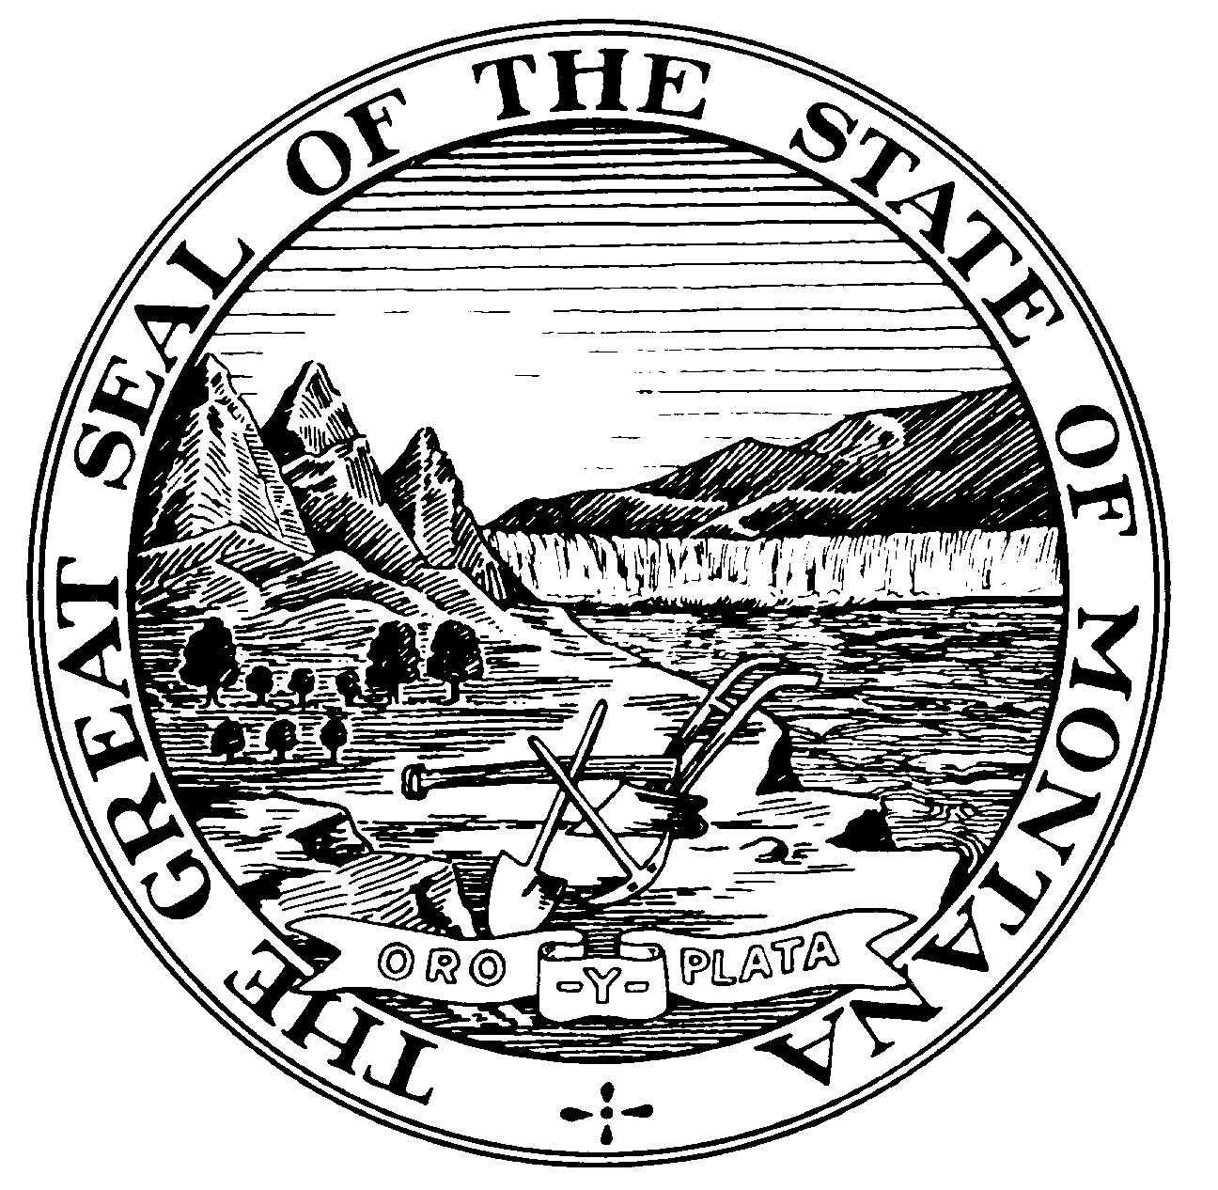
STATE OF MONTANA
RISK MANAGEMENT & TORT DEFENSE
DEPARTMENT OF ADMINISTRATION
PO BOX 200124 - HELENA, MT 59620-0124
(406) 444-2421 FAX (406) 444-2592
REPORT OF INCIDENT
COMPLETE ONLY THE SECTION THAT APPLIES TO YOUR LOSS
VEHICLE PERSONAL INJURY PROPERTY DAMAGE / OR LOSS
Reporting Person: |  |  |  |  |  |  |  | Job Title:
Department: |  |  |  |  |  |  |  | Division: |  |  |  |  |  |  |  |  |  |  |  |  |  | Phone:
Date/Time of Incident: |  |  |  |  | Location of Incident:
VEHICLE LOSS

ACCIDENT INFORMATION
Were Police Notified? Yes No |  |  |  |  |  |  |  |  | Police Department Name:
Investigating Officer’s Name: |  |  |  |  |  |  |  |  |  |  | Investigation Officers Phone Number
Were Citations Issued? No Yes STATE Vehicle Driver OTHER Vehicle Driver
Weather Conditions: Clear? Rain? Snow? Other? Describe
Roadway Conditions: Dry? Wet? Icy? Snow packed? Other? Describe
Light Conditions: Daylight? Darkness? Dusk? Dawn? Other? Describe
Vehicle Speed: STATE Vehicle? OTHER Vehicle?
License No. ______________________  Est. Repair_ ______________________ |  |  |  | Attachment No._ _____________________  Est. Repair__ ________________________ |  |  |  |  |  |  |  |  |  |  |  | Attachment No._ _____________________  Est. Repair_ _________________________
Describe Accident/Incident in detail:  (use blank paper for additional information) |  |  |  |  |  |  |  |  |  |  |  |  |  | Accident Diagram  INDICATE  NORTH  BY ARROW  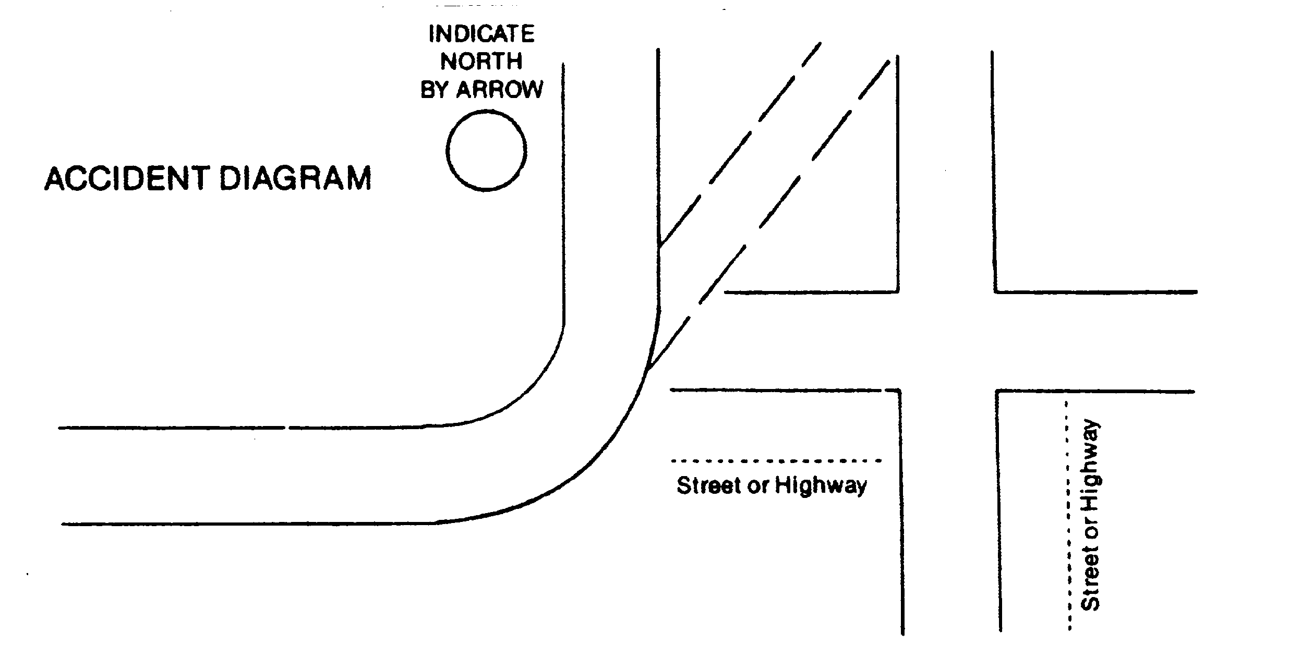
Signature of Driver: |  |  |  |  |  |  |  |  |  |  |  |  |  |  |  |  | Date:
STATE VEHICLE INFORMATION
Department Owning Vehicle: |  |  |  |  |  |  |  |  |  |  |  |  |  |  |  |  |  |  |  |  |  |  | Phone No.
Driver’s Name: |  |  |  |  |  |  |  |  |  |  |  |  |  |  |  |  |  |  |  |  |  |  | Phone No.
For What Purpose was the Vehicle Being Used?
Plate No. |  |  |  |  |  | VIN No. |  |  |  |  |  |  |  |  |  |  |  | Make/Model/Year:
Location Where Vehicle May Be Seen (Address)? |  |  |  |  |  |  |  |  |  |  |  |  |  |  |  |  |  | Equip. No.
OTHER VEHICLE INFORMATION
Plate No./State: |  | VIN No.: |  |  |  |  |  |  |  |  |  |  | Make/Model/Year:
Owner Name:
Address: |  |  |  |  |  |  |  |  |  |  |  |  |  |  |  |  |  |  |  | Phone No.:
Driver’s Name:
Address: |  |  |  |  |  |  |  |  |  |  |  |  |  |  |  |  |  |  |  | Phone No.:
Insurance Co.: |  |  |  |  |  |  | Policy No.: |  |  |  |  |  |  |  |  |  |  |  |  | Phone No.:
OCCUPANTS
Name: |  |  | Address: |  |  |  |  |  |  | Age |  | State  Veh. |  |  | Other  Veh. |  |  |  | Injured  Y - N |  |  |  |  | Describe Injury
WITNESSES
Name: |  |  | Address: |  |  |  |  |  |  |  |  |  |  |  | Phone:
PERSONAL INJURY
Name of Injured: |  |  |  |  | Address: |  |  |  |  |  |  |  |  |  |  |  |  |  |  |  | Phone:
Nature of Injury:
Describe clearly how accident/injury occurred:

(use blank paper for additional information)

PROPERTY DAMAGE / OR LOSS
State Property Other
Describe clearly how property damage occurred:

(use blank paper for additional information)
Property Description (Give make, model, serial number when applicable)

(use blank paper for additional information)

Date | Reporting Person’s Signature:
Date | Supervisor’s Signature:
Date | Department Official’s Signature:

REPORT OF INCIDENT
COMPLETE ONLY THE SECTION THAT APPLIES TO YOUR LOSS
VEHICLE PERSONAL INJURY PROPERTY DAMAGE / OR LOSS
Reporting Person: |  |  |  | Job Title:
Department: |  |  |  | Division: |  |  |  |  |  |  | Phone:
Date/Time of Incident: |  | Location of Incident:
VEHICLE LOSS

ACCIDENT INFORMATION
Were Police Notified? Yes No |  |  |  |  | Police Department Name:
Investigating Officer’s Name: |  |  |  |  |  | Investigation Officers Phone Number
Were Citations Issued? No Yes STATE Vehicle Driver OTHER Vehicle Driver
Weather Conditions: Clear? Rain? Snow? Other? Describe
Roadway Conditions: Dry? Wet? Icy? Snow packed? Other? Describe
Light Conditions: Daylight? Darkness? Dusk? Dawn? Other? Describe
Vehicle Speed: STATE Vehicle? OTHER Vehicle?
License No. ______________________  Est. Repair_ ______________________ | Attachment No._ _____________________  Est. Repair__ ________________________ |  |  |  |  |  |  | Attachment No._ _____________________  Est. Repair_ _________________________
Describe Accident/Incident in detail:  (use blank paper for additional information) |  |  |  |  |  |  | Accident Diagram  INDICATE  NORTH  BY ARROW
Signature of Driver: |  |  |  |  |  |  |  |  | Date:
STATE VEHICLE INFORMATION
Department Owning Vehicle: |  |  |  |  |  |  |  |  |  |  |  | Phone No.
Driver’s Name: |  |  |  |  |  |  |  |  |  |  |  | Phone No.
For What Purpose was the Vehicle Being Used?
Plate No. |  |  | VIN No. |  |  |  |  |  |  | Make/Model/Year:
Location Where Vehicle May Be Seen (Address)? |  |  |  |  |  |  |  |  |  | Equip. No.

Tort Claims Report of Incident Form - Continued
OTHER VEHICLE INFORMATION
Plate No./State: |  | VIN No.: |  |  |  |  |  | Make/Model/Year:
Owner Name:
Address: |  |  |  |  |  |  |  |  |  |  | Phone No.:
Driver’s Name:
Address: |  |  |  |  |  |  |  |  |  |  | Phone No.:
Insurance Co.: |  |  |  |  | Policy No.: |  |  |  |  |  | Phone No.:
OCCUPANTS
Name: |  |  | Address: |  |  | Age | State  Veh. |  | Other  Veh. | Injured  Y - N |  |  | Describe Injury
WITNESSES
Name: |  |  | Address: |  |  |  |  |  | Phone:
PERSONAL INJURY
Name of Injured: |  |  |  | Address: |  |  |  |  |  |  |  | Phone:
Nature of Injury:
Describe clearly how accident/injury occurred:

(use blank paper for additional information)

PROPERTY DAMAGE / OR LOSS
State Property Other
Describe clearly how property damage occurred:

(use blank paper for additional information)
Property Description (Give make, model, serial number when applicable)

(use blank paper for additional information)

Date | Reporting Person’s Signature:
Date | Supervisor’s Signature:
Date | Department Official’s Signature:

EMPLOYEE ACKNOWLEDGMENT

______________________________
Printed Employee Name

has read and agrees to follow MSDB’s “HEALTH AND SAFETY PROGRAM MANUAL”. I further acknowledge that I have read the safety/health policies and agree to abide by policies/procedures listed and as augmented and/or amended by the administration. I understand that my failure to follow school safety policies and procedures may result in disciplinary action being taken against me up to and including termination from employment with MSDB.

__________________________________________ ____________________________
Employee Signature Date

cc: Personnel File

