ON CAMPUS EVENT
April 8 & 9, 2022
FRIDAY Noon to 9:00 pm
SATURDAY 9:00 am – 2:00 pm

FEATURING:
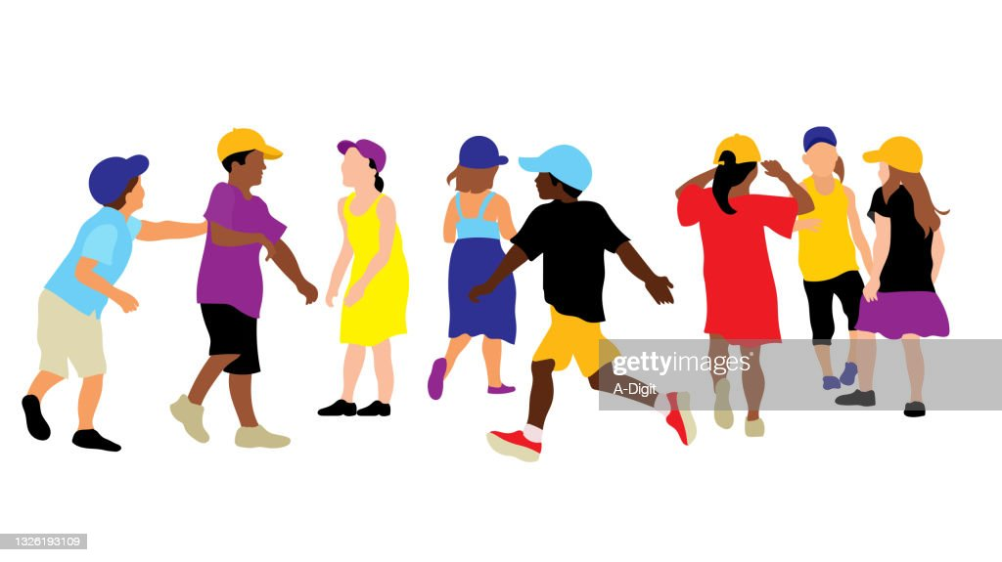
SOCIALIZING & MOVEMENT

Agenda:
Friday
Noon -1 - Lunch
1-3 - Socializing and Games/Tech
3-5 - Showdown
5-6:30 - Supper
6:30-9:00 - Goalball/Movie

Saturday
9-noon - ECC Activities
Noon - Lunch
1-2 - Closing Activity

Google registration form can be completed here: https://forms.gle/ReFvrhDn5bMYVv6B6
OR call your consultant to help you complete it over the phone.
Registration deadline: April 3, 2022

