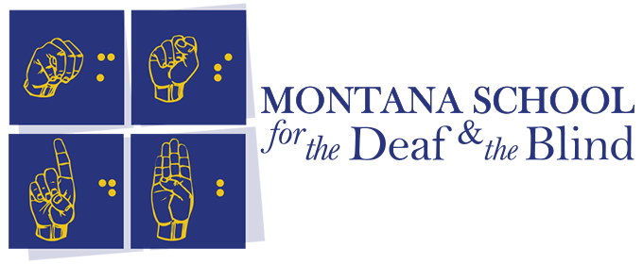

REGISTRATION NOW OPEN!

Spring View

(Visually Impaired Enrichment Weekend)

CODE WIZARDS!!

JOIN US to explore APH PRODUCTS:

Code N’ Go Mouse

Code Jumper

Code Quest

*Presented by MSDB Outreach and Educational Staff*

Braille Code For Fun

*Presented by MSDB Campus Staff*

Secret Code Sports

*Presented by the Northwest Association for Blind Athletes.*

MSDB is offering yet another amazing weekend for students K-12 **on campus**, April 21-22. Your child does not need to know “coding” to have fun – Along with these activities we will be swimming, enjoying a pizza party, and more! REGISTER ASAP! REGISTRATION CLOSES APRIL 11TH.

For registration and more go to the MSDB webpage or click [HERE](https://www.msdbmustangs.org/outreach/student-events/).

