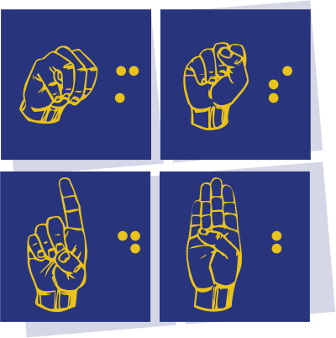
Braille-Untangling the Dots
For Those Providing Instruction to Braille Students in Montana
March 17, 2023
Virtual Event through ZOOM

Friday, March 17 – 8:00 am – 4:00 pm

Friday -
8:00 Check in –
- Welcome
- Explanation of schedule and introductions
- Welcome message by Allison
8:30am – 4:00 Braille Sessions
Choose from one of the following:
- Intro to Braille room:
Introduction to braille, Introduction to Perky Duck, APH Course introduction, and Lessons 1 and 2 in the Transcribers course. This room is monitored by MSDB Outreach.
- Quiet Work Room:
Quiet work space to work on your assignments. Can ask each other or staff questions as you are working. This room is monitored by MSDB Outreach
- The Main Room – Activity Room. Allison will be here for you to discuss your assignments. This room is monitored by MSDB Outreach.
LUNCH – We will leave the rooms open – take lunch or breaks on your own time.
You can move between rooms.

REGISTRATION INFORMATION:
- Copy and paste this link in your browser to register for this event: https://forms.gle/9SkBixwHN6wXtjtt8
- CEUs will be offered.

